- Sable Pahle Application me Upper 
2 -
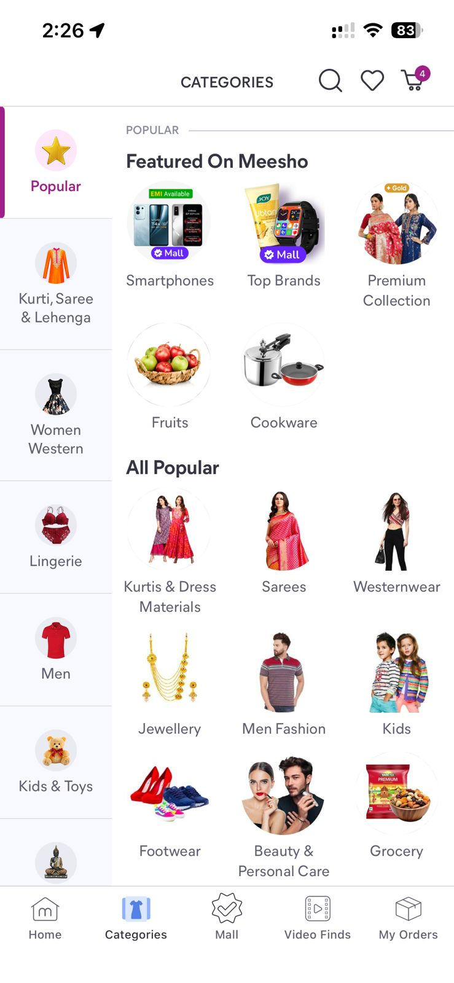
3 - First Line me jo Hai na mehndi Haldi wo sahih Hai
4- Banner Ke niche main Category ko chota krna hai ek line me 4 ayega or uske niche4 total 8 ayega
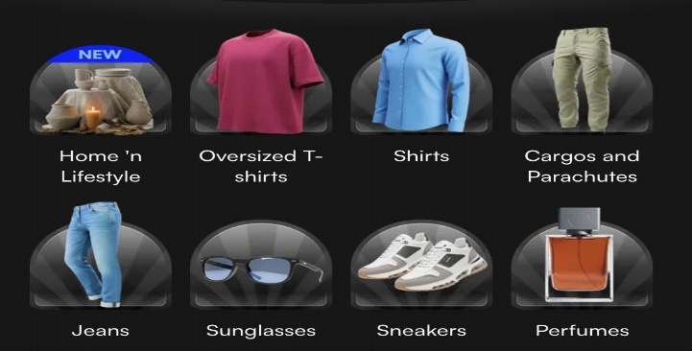

5 – Banner Sliding kijye thoda effect ke sath
6- Continue product dont end that
7- Share Button On Product Page

